Exercise 1: Mocking and Stubbing

**Step 1:- . Created a mock object for the external API.**

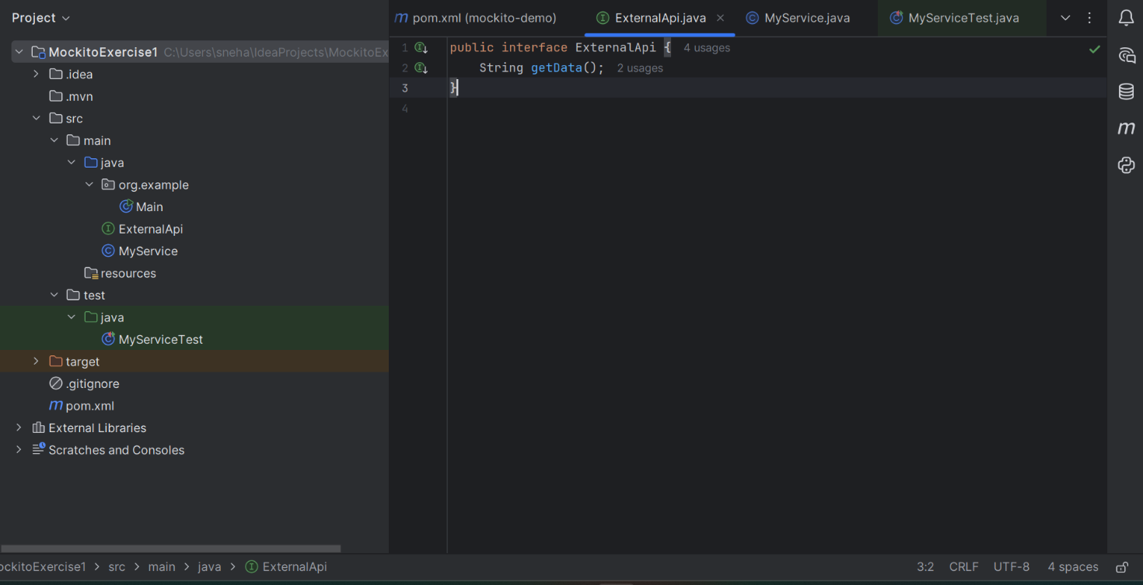

**Step 2:- Stub the methods to return predefined values**.

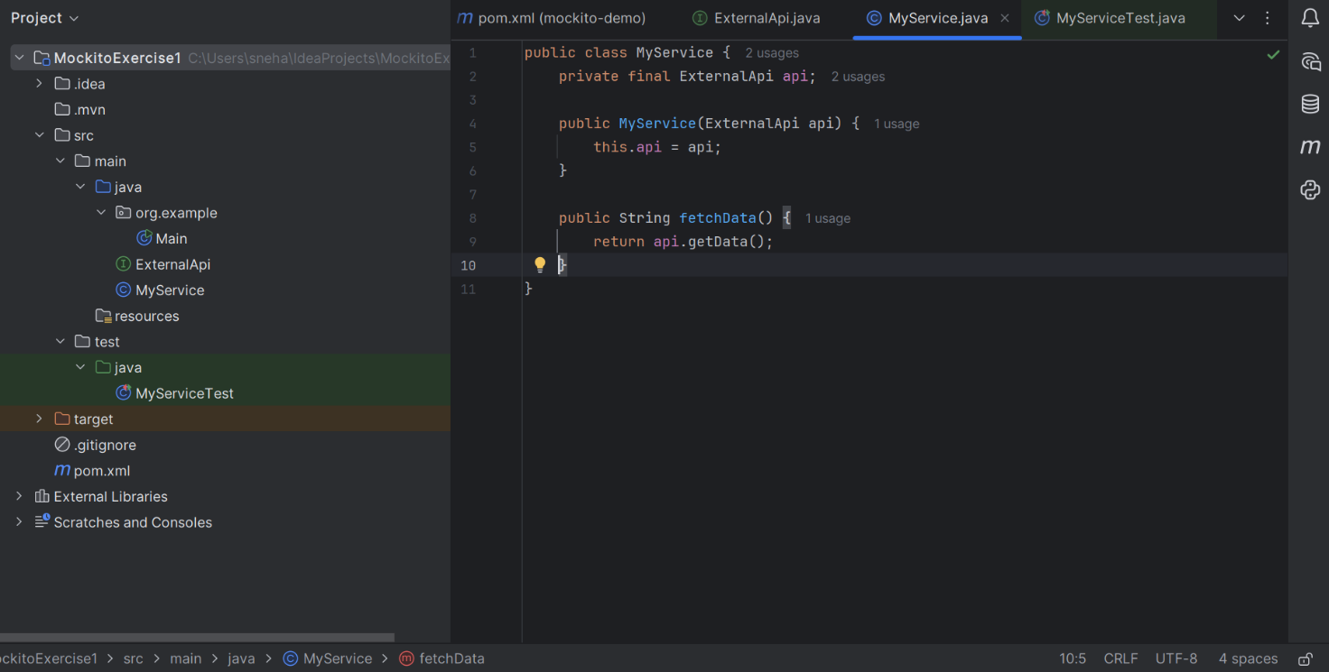

**Step 3:- Test case that uses the mock object.**

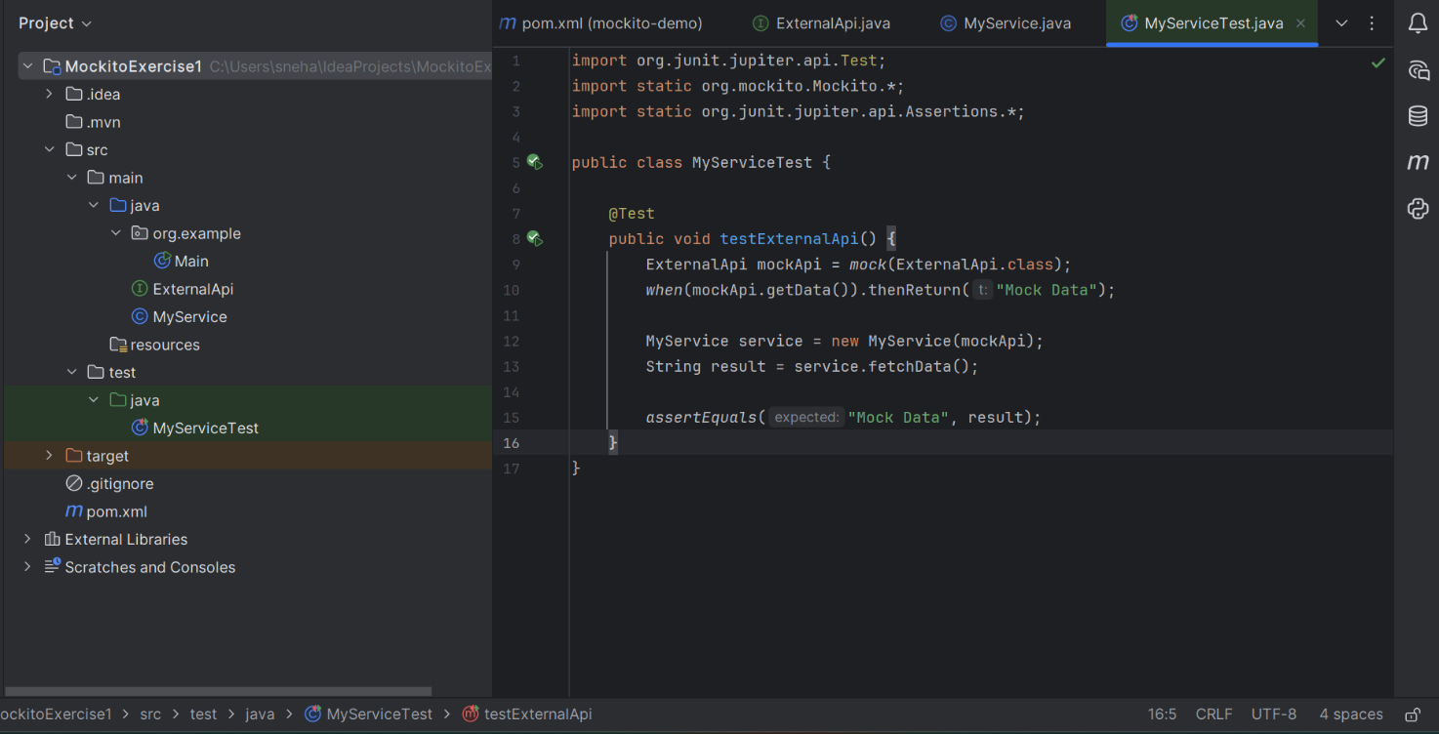

**OUTPUT:**

